ASSIGNMENT 4

**Assignment Date :01 November 2022 Student Name :Aravind.C Student Roll no : 19CEIT003**

**Maximum Marks : 2 marks**

**Project Title : IOT based safety gadget for child**

**Monitoring& Notification**

**Write code and connections in wokwi for ultrasonic sensor. Whenever distance is less than 100cms send "alert" to IBM cloud and display in device recent events.**

# CODE:

#include

<WiFi.h>#include<PubSub Client.h>

voidcallback(char*subscribetopic,byte*payload,unsignedintpayloa dLength);

#defineORG"3cghy5"

#defineDEVICE_TYPE"Childsafty"

#defin e DEVICE_ID "2631"

#defineTOKEN"87654321"

Stringdata3;

char server[] = ORG ".messaging.internetofthings.ibmcloud.com";

charpublishTopic[]= "iot-2/evt/Data/fmt/json";

charsubscribetopic[]= "iot- 2/cmd/test/fmt/String";

charauthMethod[]="use- token-auth";

chartoken[]=TOKEN; charclientId[]="d:"ORG":"DEVICE_TYPE":"DEVICE_ID;

WiFiClientwifiClient; PubSubClient client(server, 1883,

callback ,wifiClient);const inttrigPin=5; constintechoPin=18; #defineSOUND_SPEED0.034l ongduration;

float distance;voids etup(){

**Serial**.begin(115200);pinMo de(trigPin,OUTPUT);pinMo de(echoPin, INPUT);wificonnect(); mqttconnect();

}

voidloop()

{

digitalWrite(trigPin,LOW);delayMi croseconds(2);digitalWrite(trigPin, HIGH);delayMicroseconds(10);digi talWrite(trigPin,LOW);duration=pu lseIn(echoPin,HIGH);

distance= duration*SOUND_SPEED/2;**Serial**.print("Distan ce(cm): ");**Serial**.println(distance); if(distance<100)

{

**Serial**.println("ALERT!!"); delay(1000);PublishData(d istance);delay(1000); if(!client.loop())

{mqttconnect();

}

}

delay(1000);

}

voidPublishData(floatdist)

{mqttconnect(); String payload =

"{\"Distance\":";payload+=dist; payload

+=",\"ALERT!!\":""\"Distancelessthan100cms\"";payload+="}";

**Serial**.print("Sendingpayload:"); **Serial**.println(payload);

if(client.publish(publishTopic,(char*)payload.c_str())){

**Serial**.println("Publishok");

}else{

**Serial**.println("Publishfailed");

}

}

voidmqttconnect(){ if(!client.connected())

{**Serial**.print("Reconnectingclientto");**Serial**.printl n(server); while(!!!client.connect(clientId,authMethod,token)){ **Serial**.print(".");

delay(500);

}

initManagedDevice();

**Serial**.println();

}

}

voidwificonnect()

{

**Serial**.println();**Serial**.print("Connect ing to ");WiFi.begin("Wokwi- GUEST","",6);

while(WiFi.status()!=WL_CONNECTED)

{delay(500);

**Serial**.print(".");

}

**Serial**.println("");**Serial**.println(" WiFiconnected");**Serial**.println("I Paddress: ");**Serial**.println(WiFi.localIP());

}

voidinitManagedDevice(){

if (client.subscribe(subscribetopic))

{**Serial**.println((subscribetopic));**Serial**.println("su bscribetocmdOK");

}else{

**Serial**.println("subscribetocmdFAILED");

}

}

voidcallback(char*subscribetopic,byte*payload,unsignedintpayloadLength)

{

**Serial**.print("callbackinvokedfortopic:"); **Serial**.println(subscribetopic);

for (inti=0; i<payloadLength;i++){

//Serial.print((char)payload[i]); data3+=(char)payload[i];

}

**Serial**.println("data:"+data3);da ta3="";

}

# CIRCUIT DIAGRAM:

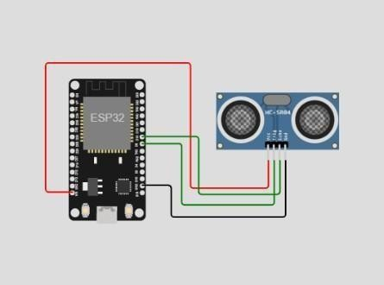

OUTPUT:

